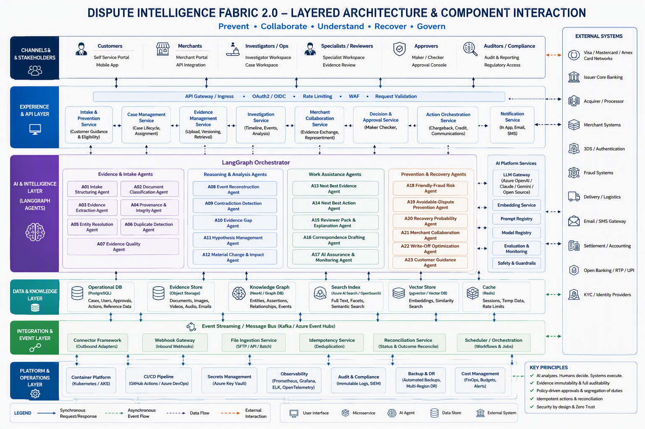

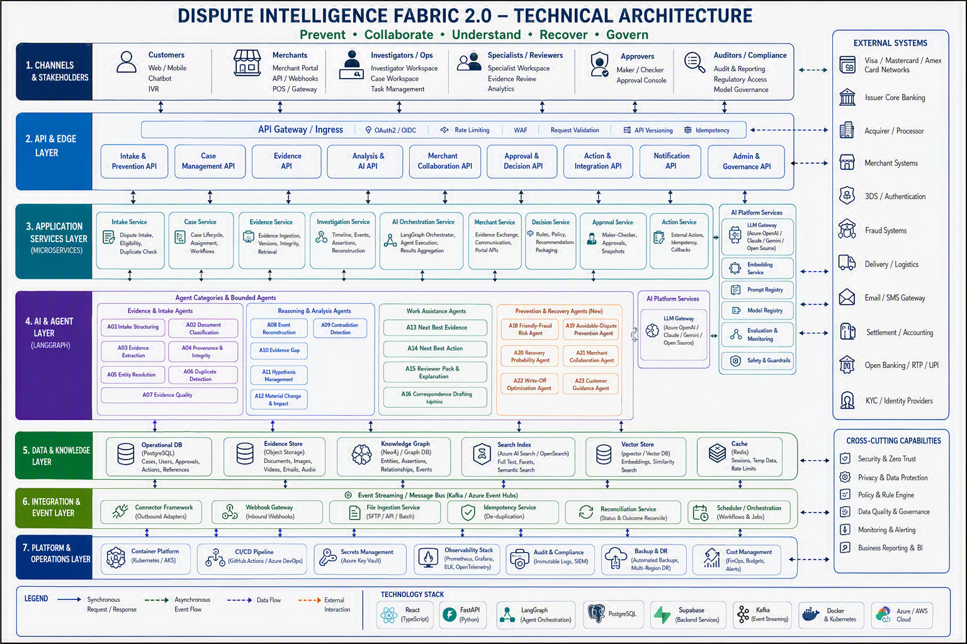

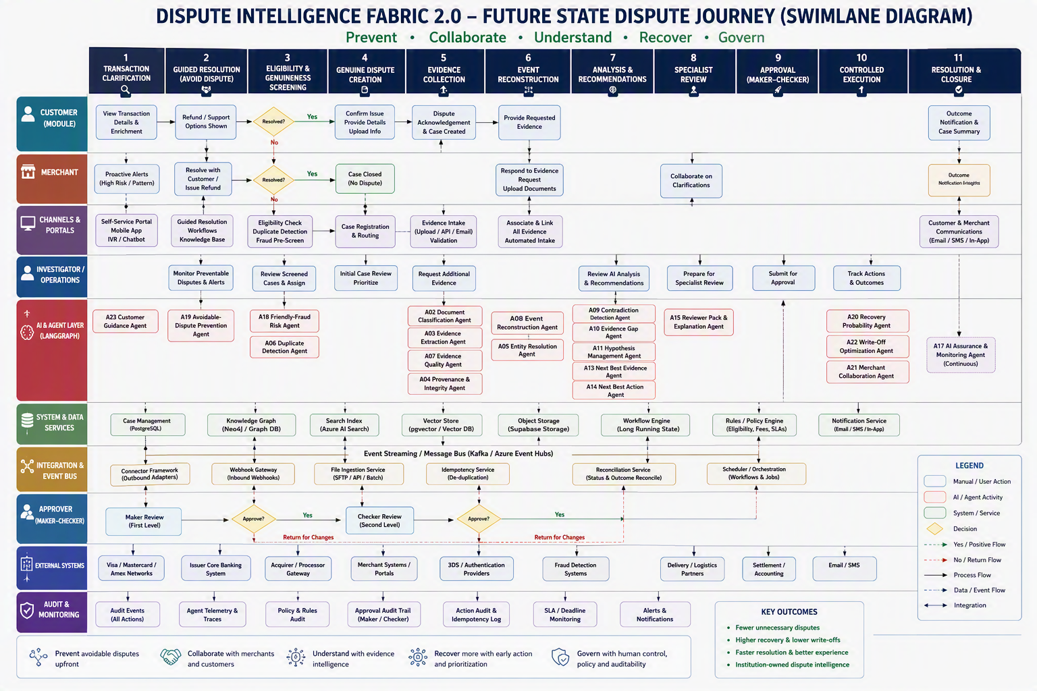

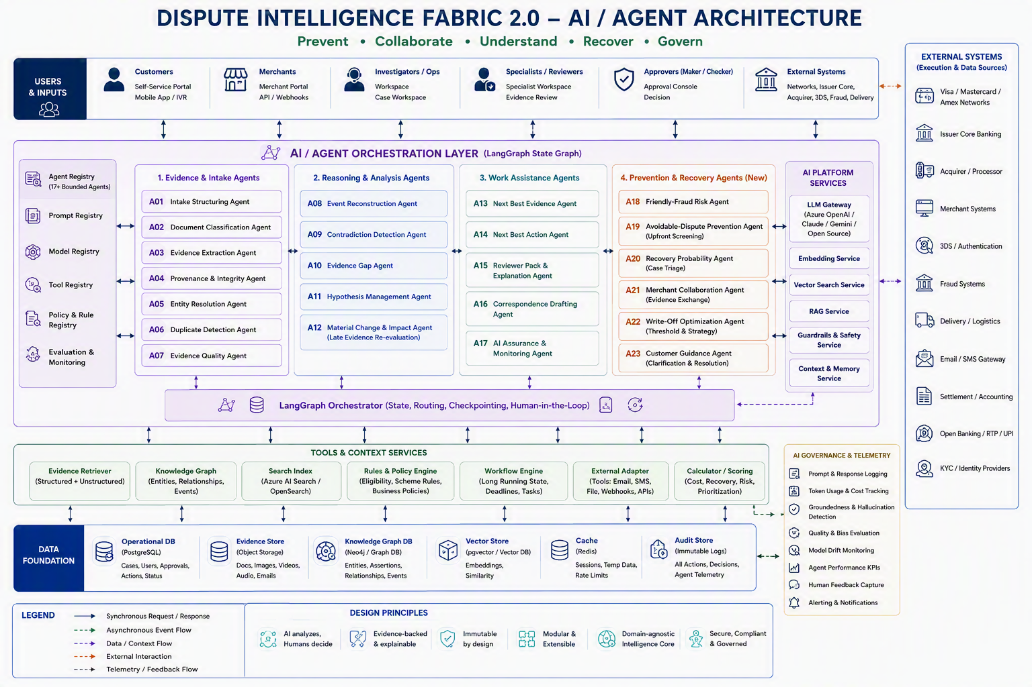

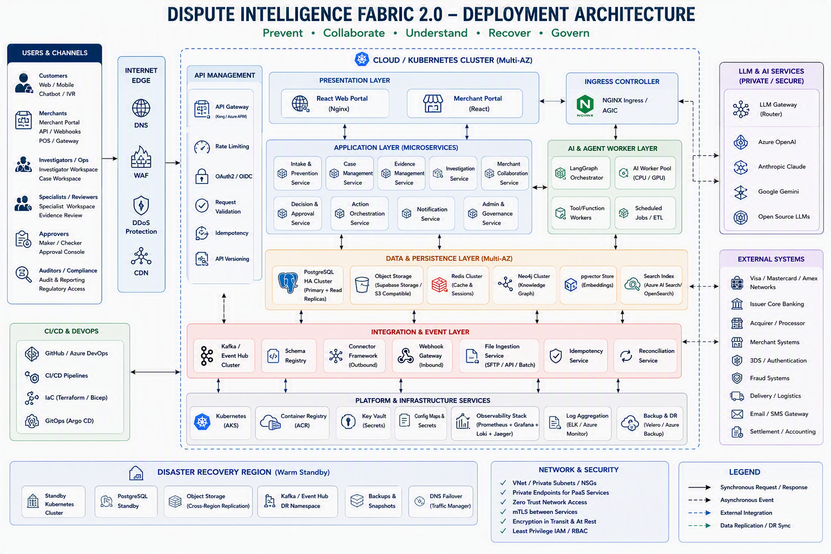

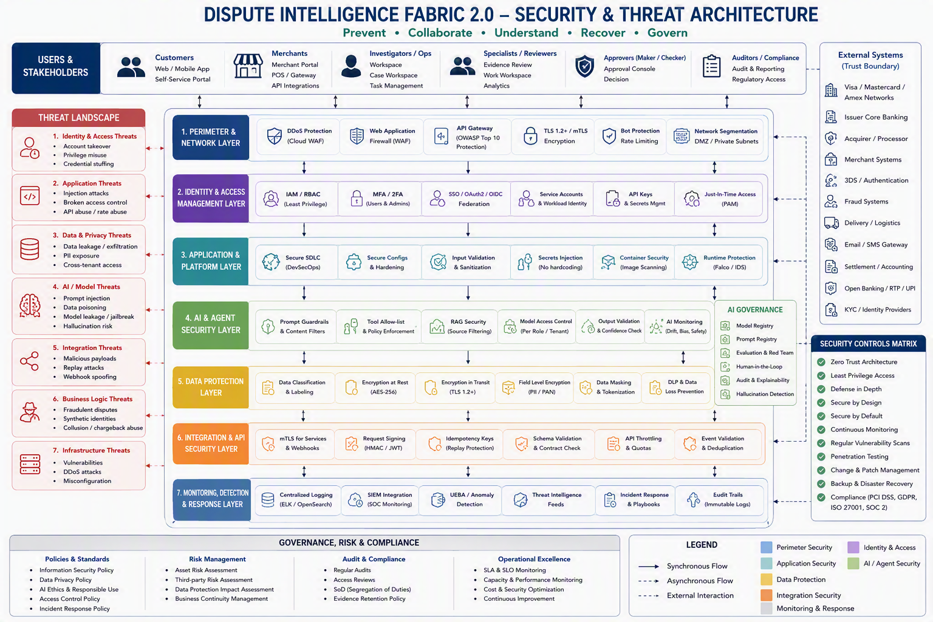

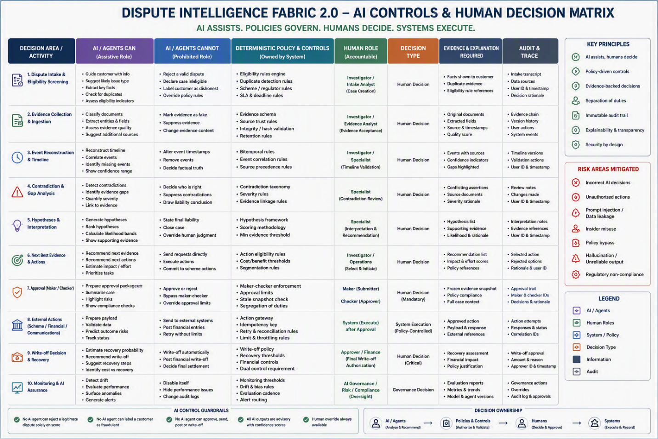

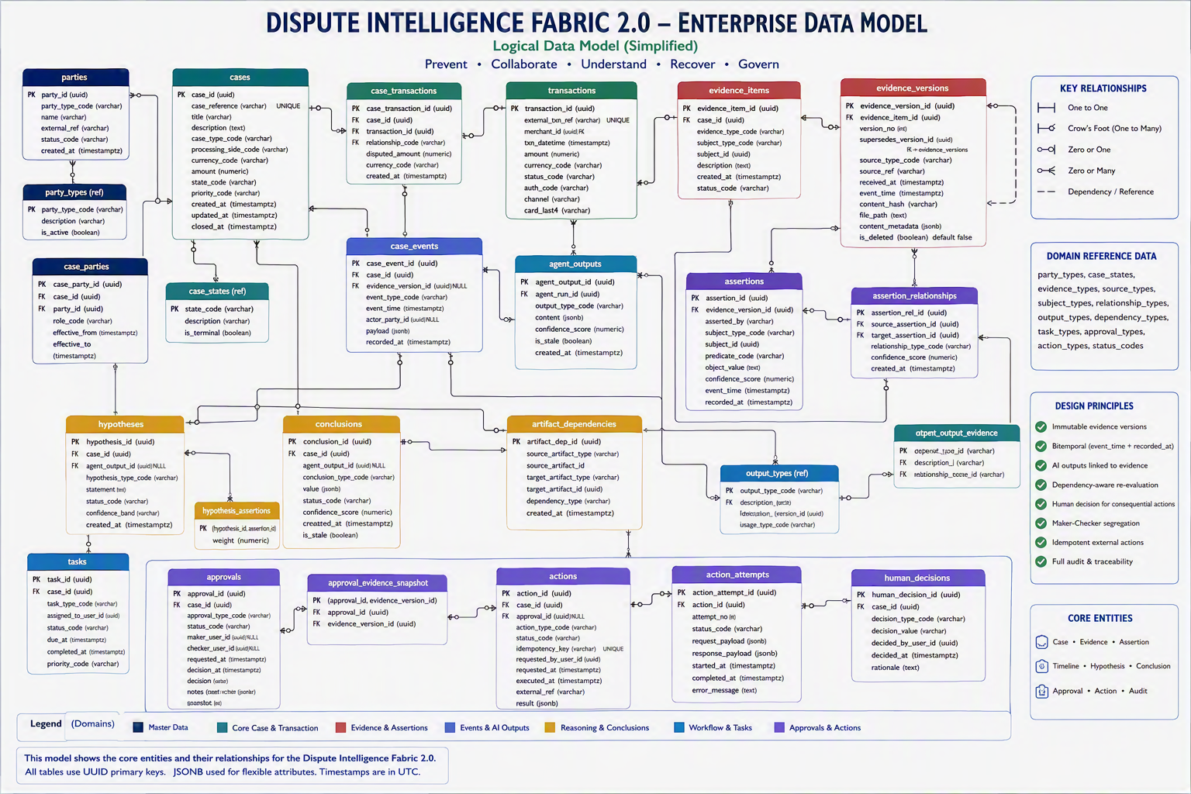

How to use these screens to generate code
The package contains 40 files, including:
Plain Text
1
DIF_All_Actor_Screen_Designs/
2
├── png/
3
│ └── 12 high-resolution screen designs
4
├── html/
5
│ └── 12 responsive HTML screen references
6
├── specs/
7
│ └── 12 JSON functional screen specifications
8
├── design-system/
9
│ ├── design-tokens.json
10
│ └── tokens.css
11
├── SCREEN_INVENTORY.json
12
└── README.md
Show more lines
How to use the pack for React code generation
- Use each PNG as the visual acceptance reference.
- Use the corresponding HTML file as the semantic layout reference.
- Use the JSON specification for route behaviour, actor needs, actions, responsive rules and accessibility requirements.
- Use design-tokens.json or tokens.css to maintain consistent colors, spacing, typography and component radii.
- Build the shared components identified in each JSON specification:
  - AppShell
  - RoleNavigation
  - PageHeader
  - KpiCard
  - JourneyStepper
  - EvidencePanel
  - ActionBar
  - HumanControlBanner
All displayed values are explicitly synthetic design references. Production identity, authorization, scheme rules, financial actions, privacy, accessibility and audit controls still require institution-specific implementation and validation.

Sequence diagrams

ALos give me all dispute cases details which can be handled without human intervention thru AI intervention which tradinally is human dependent

Dispute Cases That Can Be Handled End-to-End by AI With No Human Touch
These are cases where AI confidence is high, evidence is complete, and policy rules permit automatic resolution.
1. Duplicate Dispute Raised
Traditional Human Work
- Check whether dispute already exists
- Compare transaction references
- Close duplicate case
AI Automation
- Detect duplicate dispute
- Link to master case
- Inform customer automatically
Auto Resolution: ✅

2. Refund Already In Progress
Traditional Human Work
- Verify refund request
- Check merchant refund system
- Explain to customer
AI Automation
- Detect refund initiated
- Calculate expected settlement date
- Notify customer
Auto Resolution: ✅

3. Refund Already Completed
Traditional Human Work
- Verify refund credit
- Close dispute manually
AI Automation
- Match refund to transaction
- Show refund evidence
- Auto-close dispute
Auto Resolution: ✅

4. Customer Doesn't Recognize Merchant Name
Your solution already includes merchant recognition and transaction enrichment. [Writeoff_R...n_Strategy | Word], [Dispute_In...on_25min 1 | PowerPoint]
Examples
- UBER BV instead of Uber
- AMZN MKTPLACE rather than Amazon
AI Automation
- Explain merchant descriptor
- Show merchant logo/location
- Present receipt/order history
Auto Resolution: ✅

5. Delivery Still In Transit
Traditional Human Work
- Investigate shipment
- Contact merchant
AI Automation
- Retrieve logistics data
- Show real-time tracking
- Estimate delivery date
Auto Resolution: ✅

6. Subscription Dispute
Traditional Human Work
- Check subscription agreement
- Verify customer consent
AI Automation
- Retrieve signup evidence
- Show accepted terms
- Present cancellation options
Auto Resolution: ✅ (Low-risk scenarios)

7. ATM Cash Withdrawal Dispute With Strong Telemetry
Where:
- ATM logs available
- Camera evidence available
- Cash-dispense signals available
AI Automation
- Correlate ATM telemetry
- Generate investigation report
- Auto recommend outcome
Auto Resolution: ✅ for high-confidence cases

8. Friendly Fraud Cases
Your prevention framework specifically targets friendly fraud detection. [Writeoff_R...n_Strategy | Word]
Indicators
- Previous successful deliveries
- Customer received goods
- Prior similar behaviour
AI Automation
- Evidence aggregation
- Pattern detection
- Merchant collaboration
Auto Resolution: ✅ where evidence score exceeds threshold

9. Merchant Cancellation Already Processed
AI Actions
- Obtain cancellation proof
- Retrieve refund confirmation
- Close case automatically
Auto Resolution: ✅

10. Small Value Disputes Below Recovery Threshold
Your recovery optimization strategy includes threshold-based handling. [Writeoff_R...n_Strategy | Word], [Solution_A...Fabric_2.0 | Word]
AI Actions
- Assess recovery probability
- Compare handling cost
- Apply policy-based resolution
Auto Resolution: ✅

Cases AI Can Investigate but Human Usually Approves
11. Card Present Fraud
AI can:
- Correlate EMV data
- Analyze PIN usage
- Examine merchant history
Human approves liability decision.
Auto Resolution: ⚠️ Partial

12. Card Not Present Fraud
AI can:
- Review device fingerprints
- Analyze geolocation
- Evaluate authentication logs
Human approves.
Auto Resolution: ⚠️ Partial

13. Goods Not Received
AI can:
- Gather delivery evidence
- Compare shipping records
- Detect contradictions
Human reviews ambiguous cases.
Auto Resolution: ⚠️ Partial

14. Services Not Rendered
AI can:
- Review service logs
- Analyze fulfillment evidence
Human approval normally required.
Auto Resolution: ⚠️ Partial

15. Chargeback Representment Preparation
Traditionally analysts spend hours assembling evidence.
AI can automatically:
- Build evidence packages
- Generate network-specific narratives
- Recommend representment strategy
Industry platforms increasingly automate evidence-gathering and submission workflows. [01net.it], [chargeflow.io]
Auto Resolution: ⚠️ Human submits/approves

Cases That Should Never Be Fully Automated
Your own architecture explicitly keeps these under human or deterministic authority. [Solution_A...Fabric_2.0 | Word], [14_AI_Inte...nt_Catalog | Word]
Human Must Remain Accountable
- Fraud determination
- Criminal activity declaration
- Provisional credit approval
- Chargeback approval
- Representment approval
- Arbitration decisions
- Customer liability decisions
- Merchant liability decisions
- Write-off decisions
- Regulatory exceptions
- Legal escalations
- High-value disputes
- Reputationally sensitive cases
Auto Resolution: ❌

For Your Jury Presentation
The strongest story is:
Today (Human Dependent)
- Duplicate checks
- Evidence gathering
- Merchant outreach
- Timeline reconstruction
- Contradiction analysis
- Classification
- Missing evidence identification
- Case prioritization
- Recovery assessment
- Status communication
Future State (AI Driven)
- 70-90% of dispute operations automated
- Humans focus only on:
  - Liability
  - Approval
  - Arbitration
  - Exceptions
  - Regulatory decisions
Result
- 60-80% reduction in operational effort
- Faster dispute resolution
- Lower write-offs
- Reduced friendly fraud
- Improved chargeback success rates
- Better customer experience
- Better merchant experience
Humans no longer spend time searching for evidence, reconstructing timelines, chasing merchants, or preparing chargeback packages. AI performs those activities autonomously. Humans intervene only where liability, financial exposure, regulatory accountability, or customer rights are involved." [14_AI_Inte...nt_Catalog | Word], [Solution_A...Fabric_2.0 | Word]

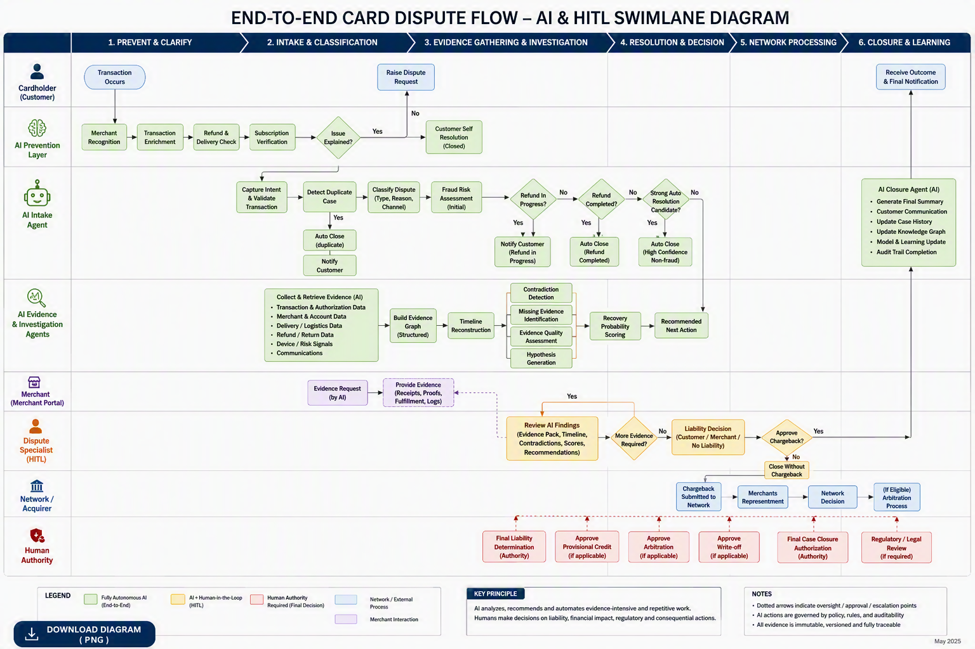

After reviewing your Dispute Intelligence Fabric vision, I believe the single winning feature is not another dispute workflow, chatbot, chargeback automation, or AI investigator. Most tier-1 banks are already investing in those.
The Winning Feature
Autonomous Dispute Prevention & Resolution Network (ADPRN)
A system that prevents 40-60% of disputes from ever becoming disputes by creating a real-time collaboration fabric between customer, issuer, merchant, acquirer, and card network.
This aligns directly with the prevention-first principles in your solution assets, which emphasize transaction clarification, merchant collaboration, guided intake, evidence exchange, and resolution before chargeback creation. [Solution_A...Fabric_2.0 | Word], [Dispute_In...on_25min 1 | PowerPoint], [Writeoff_R...n_Strategy | Word]

Why This Would Be Game Changing
Today every bank focuses on:
Plain Text
1
Dispute Created
2
↓
3
Investigate
4
↓
5
Chargeback
6
↓
7
Representment
8
↓
9
Arbitration
10
↓
11
Closure
12
``
Show more lines
Everyone is competing on processing disputes faster.
Your platform would compete on:
Plain Text
1
Preventing disputes completely
Show more lines
This is a much bigger business outcome.

What Makes It Unique
AI Knows Why Customer Is Raising Dispute Before Case Creation
Customer clicks:
"I don't recognize this transaction"
Instead of opening a dispute:
AI immediately explains:
Plain Text
1
Merchant = ABC Travel
2

3
Actual Merchant Brand = Booking.com
4

5
Hotel Stay = Hyatt Mumbai
6

7
Booking Date = 12 Aug
8

9
Check-in Date = 1 Sep
10

11
Invoice Available
Show more lines
Customer says:
Plain Text
1
Oh yes, that's mine.
Show more lines
Dispute eliminated.
This capability is already consistent with merchant recognition and transaction enrichment concepts captured in your assets. [Writeoff_R...n_Strategy | Word], [Dispute_In...on_25min 1 | PowerPoint]

Merchant Copilot
Instead of:
Plain Text
1
Issuer requests evidence
2
Merchant receives email
3
Merchant searches documents
4
Merchant uploads proof
Show more lines
AI automatically:
- Finds invoice
- Finds POS receipt
- Finds shipping proof
- Finds delivery proof
- Finds refund status
- Finds customer communication
without merchant involvement.

Live Evidence Network
Current reality:
Plain Text
1
Customer opens dispute
2
↓
3
Bank waits 20 days
4
↓
5
Merchant responds
Show more lines
Your vision:
Plain Text
1
Customer clicks Raise Dispute
2

3
Within Seconds
4

5
Merchant AI responds
6

7
"Refund already initiated"
8

9
OR
10

11
"Package delivered"
12

13
OR
14

15
"Replacement dispatched"
Show more lines
Case disappears before becoming chargeback.

Refund Rescue Engine
One of the largest sources of disputes:
Plain Text
1
Refund pending
2
``
Show more lines
AI identifies:
Plain Text
1
Refund initiated
2
Settlement expected tomorrow
Show more lines
Customer receives timeline.
Dispute never created.

Universal Transaction Story
This is probably the strongest jury concept.
For every transaction:
AI automatically builds
Transaction Digital Twin
Contains:
- Authorization
- Authentication
- Device
- Location
- Merchant
- Receipt
- Customer interaction
- Delivery
- Return
- Refund
- Chargeback
One living evidence graph.
This strongly fits your evidence graph and evidence intelligence architecture. [Solution_A...Fabric_2.0 | Word], [14_AI_Inte...nt_Catalog | Word]

Recovery Prediction Engine
Current banks treat every dispute similarly.
Your AI predicts:
Plain Text
1
Recovery Probability = 97%
2

3
Action:
4
Immediate Chargeback
Show more lines
Or
Plain Text
1
Recovery Probability = 8%
2

3
Merchant already insolvent
4

5
Recommend no arbitration
Show more lines
This turns disputes into portfolio optimization rather than operational processing. Recovery probability scoring is already a documented theme in your internal collateral. [Writeoff_R...n_Strategy | Word]

Industry-Wide Merchant Reputation Graph
This is something banks do not have today.
AI continuously learns:
Plain Text
1
Merchant A
2
Refund Rate = 99%
3

4
Merchant B
5
Chargeback Rate = 45%
6

7
Merchant C
8
Frequently Delays Evidence
Show more lines
The platform dynamically adapts resolution strategies.
Top banks would pay for this insight because it creates a competitive advantage.

Dispute Prevention Marketplace
Most disruptive idea.
Before dispute creation:
AI asks:
Option 1
Instant Merchant Refund
Option 2
Replacement Shipment
Option 3
Partial Compensation
Option 4
Track Existing Refund
Option 5
Proceed With Dispute
Result:
Many cases never become disputes.

Why a Jury Would Love It
Most contestants will say:
"We use AI to automate disputes."
Your message becomes:
"We use AI so disputes never happen."
That is a significantly stronger narrative.

If I Were Judging
The truly differentiated headline would be:
"The World's First Autonomous Dispute Prevention Network"
Current Industry KPI
- Time to resolve dispute
Your KPI
- Disputes prevented
Current Industry Goal
- Win chargebacks
Your Goal
- Eliminate chargebacks
Current Industry Approach
- Post-dispute processing
Your Approach
- Pre-dispute intervention
Current Industry Platform
- Case Management System
Your Platform
- Dispute Intelligence Fabric
Among all the features discussed so far, Autonomous Dispute Prevention using real-time evidence collaboration, merchant connectivity, transaction digital twins, and AI-guided resolution before case creation is the feature set most likely to attract the attention of large global issuers such as Citi, JPMorgan, HSBC, Barclays, Capital One, and American Express because it directly attacks the root cause: dispute volume itself.

